Complete guide to Rilievo 4.0
Installation, evidence collection, technical reports and Codex Cloud
Version 2 · 11 October 2026 · RIL40-GUIDE-EN-20261011-R02
Rilievo 4.0 organises asset information, photographs, documents, evidence checks and draft Italian Industry 4.0 technical reports. Follow the chapters in order for first setup, even if you have never used GitHub. Quoted names refer to app commands. This is a separate product from Rilievo CE: records, settings, repositories and subscriptions do not automatically transfer between the apps.
UNVALIDATED DRAFT. Professional review is mandatory. AI may produce errors, omissions and plausible hallucinations. Every classification, requirement finding, summary and report must be checked, corrected and approved by a competent, experienced professional before use, sworn assessment or delivery to a client. A photograph, green indicator, absence of alerts or completed job does not establish tax eligibility, compliance with requirements or professional approval.
CE4U S.r.l. supplies the software and Carlo Tenca develops it: neither automatically approves, signs or swears the reports. Read the product terms and the indemnity limited to professional users in the stated circumstances. Mandatory rights and liabilities remain protected. The subscription does not commission professional work from CE4U S.r.l. or Carlo Tenca.

Contents
1 · Understand the scope and applicable scheme
2 · Prepare the device, accounts and costs
3 · Install, update and open the app
4 · Set language, profile and permissions
5 · Choose an AI engine
6 · Understand GitHub before setup
7 · Create a GitHub token and connect the app
8 · Prepare Codex Cloud on a computer
9 · Choose how cloud jobs start
10 · Run a manual task and return JSON
11 · Create the first engagement and asset records
12 · Capture the nine evidence groups
13 · Test the complete workflow with DEMO material
14 · Read requirements, findings and alerts
15 · Summaries and four PDF report types
16 · Complete professional checks before signing or delivery
17 · Export, retain and replace the device
18 · Purchases, renewal and access after expiry
19 · Resolve problems without losing records
20 · Privacy, support and licences

1 · Understand the scope and applicable scheme
The native workflow collects evidence and structures the technical checks of the legacy Industry 4.0 framework using Annex A to Italian Law 232/2016. For its first group, check O1-O5 and at least two additional requirements RU-a, RU-b and RU-c. For groups 2 and 3, examine interconnection O2 alongside professional verification of classification and other applicable conditions. Interconnection alone does not establish that an asset belongs to a qualifying item.
Annex A is not a universal catalogue for every year. Intangible assets and software require a dedicated assessment and are outside an automatic 5+2 conclusion. The app does not calculate taxes, rates, savings, deadlines, reservations or administrative obligations.
For Transition 5.0, the app can help document the technical 4.0 component. It neither performs nor certifies energy-consumption reductions, energy certificates, GSE procedures or accounting checks. The 2026 scheme requires specific classification under Annexes IV/V to Law 199/2025 and verification of its applicable conditions: do not automatically convert an A/B item. Reports for 2026 and other schemes include a HOLD requiring dedicated review before use.
The appointed expert determines scheme, scope, relevant date, current primary sources, functional classification and documents for the particular engagement. Selecting a scheme or printing a reference does not prove that all its conditions have been checked.
Primary references for each engagement: 2017 Circular 4/E and A/B annexes, MIMIT on the legacy 4.0 scheme, Transizione 5.0 and the new 2026 scheme. This guide describes the software and does not replace checking applicable rules.

2 · Prepare the device, accounts and costs
You need a compatible iPhone or iPad running iOS/iPadOS 17 or later, free space for originals, battery power and an Apple Account for purchases. Local models have additional hardware, memory and image-support requirements: check compatibility inside the app. A simulator cannot run the actual MLX models.
Cloud use also requires internet, an authorised GitHub account and a ChatGPT account with actual access to the Codex channel used. API use requires a provider account, personal key and available credit/capacity for the selected model.
The prices configured for Italy are €29.90 monthly or €299.00 annually. Both periods provide the same app functions. A 14-day introductory free trial is configured for eligible accounts: Apple checks eligibility and displays the offer actually available before confirmation. Unless cancelled, the selected paid plan starts when the trial ends. The annual plan requires one €299.00 payment in advance for each year, not twelve monthly instalments. Apple's confirmation screen determines your applicable price, currency, first charge date and conditions. The trial does not include API credit or a Codex plan. A Rilievo CE subscription is separate and does not unlock Rilievo 4.0.
ChatGPT/Codex, API usage and any chargeable GitHub services are separate. A ChatGPT plan does not automatically provide API credit. App counters are neither invoices nor guaranteed provider spending caps. Set limits and alerts in the provider account, then begin with one DEMO job. Repeated requests, research and follow-ups can consume additional capacity or incur charges.

3 · Install, update and open the app
1. Open the official Rilievo 4.0 page (https://raveng.it/rilievo40/en/). Use its App Store link when Apple publication is active; check product name and developer. If no link is available, public availability is not confirmed: contact support.
2. Download from the App Store, complete Apple's confirmation and wait for “Open”. Do not install packages from unrelated sites.
3. At first launch, read the entire notice and select its reading acknowledgement. “I have read it, continue” records reading; it neither validates a report nor creates a blanket waiver of rights.
4. For an authorised beta, install TestFlight from the App Store and follow the RAVENG invitation. A beta can expire; a test purchase is not a production purchase.
5. Before an update, device replacement or reinstall, export your engagements and verify the files. Use the App Store page/profile and Apple's displayed update options.
If installation is refused, check the system version under Settings > General > About. An icon does not prove that camera, AI or cloud work: complete the end-to-end demonstration in chapter 13.

4 · Set language, profile and permissions
1. Open “Settings” from the assessment list. Enter the professional's name and check it before producing reports. A typed name is not a signature or sworn declaration.
2. Open “App language”. “Automatic (device language)” uses Italian when the device's main language is Italian, otherwise English. You can explicitly select “Italiano” or “English”. Entered information, identifiers and historical responses remain unchanged; they are not automatically translated and approved.
3. In “Camera and arrows”, check resolution and initial arrow colour. Small images may make plates or screenshots illegible. Cloud transfers may use resized copies, while exports preserve originals actually held in the archive.
4. Grant permissions appropriate for your engagement: Camera for photographs/scans; Location while using the app for proposed address/client; Microphone and Speech Recognition for dictation; selected Photos for imports; Notifications for alerts outside the app. Check the separate photo-library copy option described below before the first shot.
5. If permission is denied, use typing, a manually checked address or imports where available. Restore permission in iOS Settings > the app or Privacy & Security; paths vary by iOS version. Use the keyboard if on-device dictation is unsupported.
Always verify a location-based client suggestion: GPS and maps can be wrong. “Local AI” describes inference, not every phone connection. Maps, downloads, purchases, iCloud files, backups and sharing may contact external services.
Copying shots to the Photos library. In Settings > Camera and arrows > “Photos library”, check “Save every shot to the Photos library”, which is initially on. If your practice does not authorise this copy, turn it off before taking photographs. With the option on, the app requests library access: full access allows creation/use of the “Rilievo 4.0” album; a copy made with limited access may have no album; with access denied, the image remains in the app archive. Inspect the actual result in Photos after one DEMO shot, without using confidential material to test a permission.
The copy preserves the full-resolution frame, date and engagement location where available; it is not a complete engagement file and does not automatically include annotations or every appraisal field. Imported photos and scanned documents are not copied again. With iCloud Photos enabled, copies may sync with the Apple Account. Deleting an engagement or turning off the option does not withdraw photographs already saved in Photos, iCloud or other backups: check these destinations separately.

5 · Choose an AI engine
Channel | Preparation | Destination of material
Local AI | Available compatible model ready on the device | On-device inference; check other phone services separately
Codex Cloud | Dedicated private repository, token, Codex access and successful test | GitHub and OpenAI; no automatic anonymisation
AI via token | Provider, personal key, model and tested connection | Selected provider and any service intermediaries

The default AI mode is “Essential”. Plate reading starts automatically; for other annotated photographs, with automatic analysis on, the app waits at least 30 seconds after the last asset change. Its periodic check may add more time: 30 seconds is not a promised response time. In Essential mode, the complete asset requirement check, document research and alert review are requested manually. Open Settings > Automations and check the mode and each switch before working; for the first test, turn off ordinary-photo automatic analysis and avoid a plate if you do not want its reading to start. “Automatic” mode may start additional processing: enable it only after a successful test and after checking privacy and costs.
When you request the engagement summary, the app may first update missing, outdated or failed checks for the main assets, then produce the summary. For a complex asset, check its boundaries and components: individual parts do not automatically become independent assessments. A new or modified image may require further analysis. Do not repeatedly tap “Refresh” or “Retry” while a job is active; note its identity and error before repeating it.
For local AI, open Settings > AI engine > Local AI and “Local AI models”. Read “Your device”, select a vision-capable model for photographs, tap “Download” and wait for its ready/in-use state. Model weights can occupy several GB. Use Wi-Fi and power before leaving for the site. Do not rely on an incomplete download or a model marked incompatible.
For API use, open Settings > AI engine > AI via token. Select the provider, read the channel disclosure, enter the key in the protected field, choose “Save and verify”, select an image-capable model and “Test connection”. Keys are held in the app's Keychain. A custom endpoint must belong to an authorised operator; a routing service may send material to further providers. A successful connection verifies access, not a technical report. Never send keys, passwords or authentication codes to support or a chat.
Ultrafast and fallback to standard. For OpenAI and a supported model, API settings let you enable Ultrafast; it is initially off. On 11 October 2026, the official API pricing for supported models applies a multiplier of 6 to standard token rates. Actual availability, separate limits and prices remain determined by the provider. If the tier is rejected or exhausted, the app may retry at standard and indicate this in the job: check the effective tier rather than just the switch. A faster answer needs the same professional review. Ultrafast API guide, gpt-6.1-sol pricing and conditions.
Check usage before repeating a request. Open Settings > “AI usage”, or the usage summary in the engagement panel. The local ledger records usage returned by API calls: connection tests, corrections and unparseable responses may also consume tokens. Check period, provider, model, activity and engagement. Uncached input, cache reads, cache writes and output tokens have different prices; web searches can add charges.
If a model has no known price, the total is incomplete: zero or a missing-price indicator does not mean “free”. Open the model and enter your contract's prices, following the displayed units: per million tokens and, where applicable, per thousand searches. Changing a price may recalculate historical estimates. Export the CSV and compare it with the provider's account statement: periods and engagements are local summaries, not invoices or certified accounts.
The API ledger does not measure Codex Cloud usage or local inference. For Codex, check your account plan, limits and any credits; do not apply the API multiplier automatically to Cloud usage. Providers may count requests the app cannot record. An app limit or estimate does not replace an effective limit set with the provider.
Euro estimates and exchange rates. Price lists are expressed in US dollars; conversion to euros uses an ECB reference or a manually entered rate. Always check the source, date and rate. An ECB reference is informative: it is not the rate your card or provider will apply to a transaction. Without a connection, an older reference may remain; a euro amount does not prove the rate is current. Retain the dollar amount and reconcile any VAT, fees and actual exchange rate with the invoice. ECB reference exchange rates.
1. In “AI usage”, compare Today, last 7 days, month and total; select the correct engagement when viewing a specific summary. Totals include recorded requests, not just usable results.
2. In “Applied prices”, open the model, check your provider contract and enter prices in the indicated units. Do not enter a per-thousand-token price in a per-million field. If your contract does not define an item, verify its treatment before completing the rates.
3. Under “Amounts in euros”, check the exchange-rate source and date. For a manual reference, use “Set manually”, enter “dollars per €1” and choose “Apply”; check that the description shows your chosen value and a manual-rate indication. Direction example: €1 = $1.1206 requires 1.1206, not its reciprocal. This is a dated example, not a permanent rate. “Back to the ECB rate” restores the available ECB reference.
4. Check monthly and total “Ultrafast surcharge”: it estimates the difference from the same calls at standard tier and is already included in the total. Do not add it to the overall cost again.
5. Export the CSV to an authorised destination, open it and reconcile dollars, euros, exchange rate and calls with the provider's statement. Summaries may change after a price/rate change. “Reset the counter” deletes the local ledger after confirmation, not the provider's invoice or CSV files/backups already created.
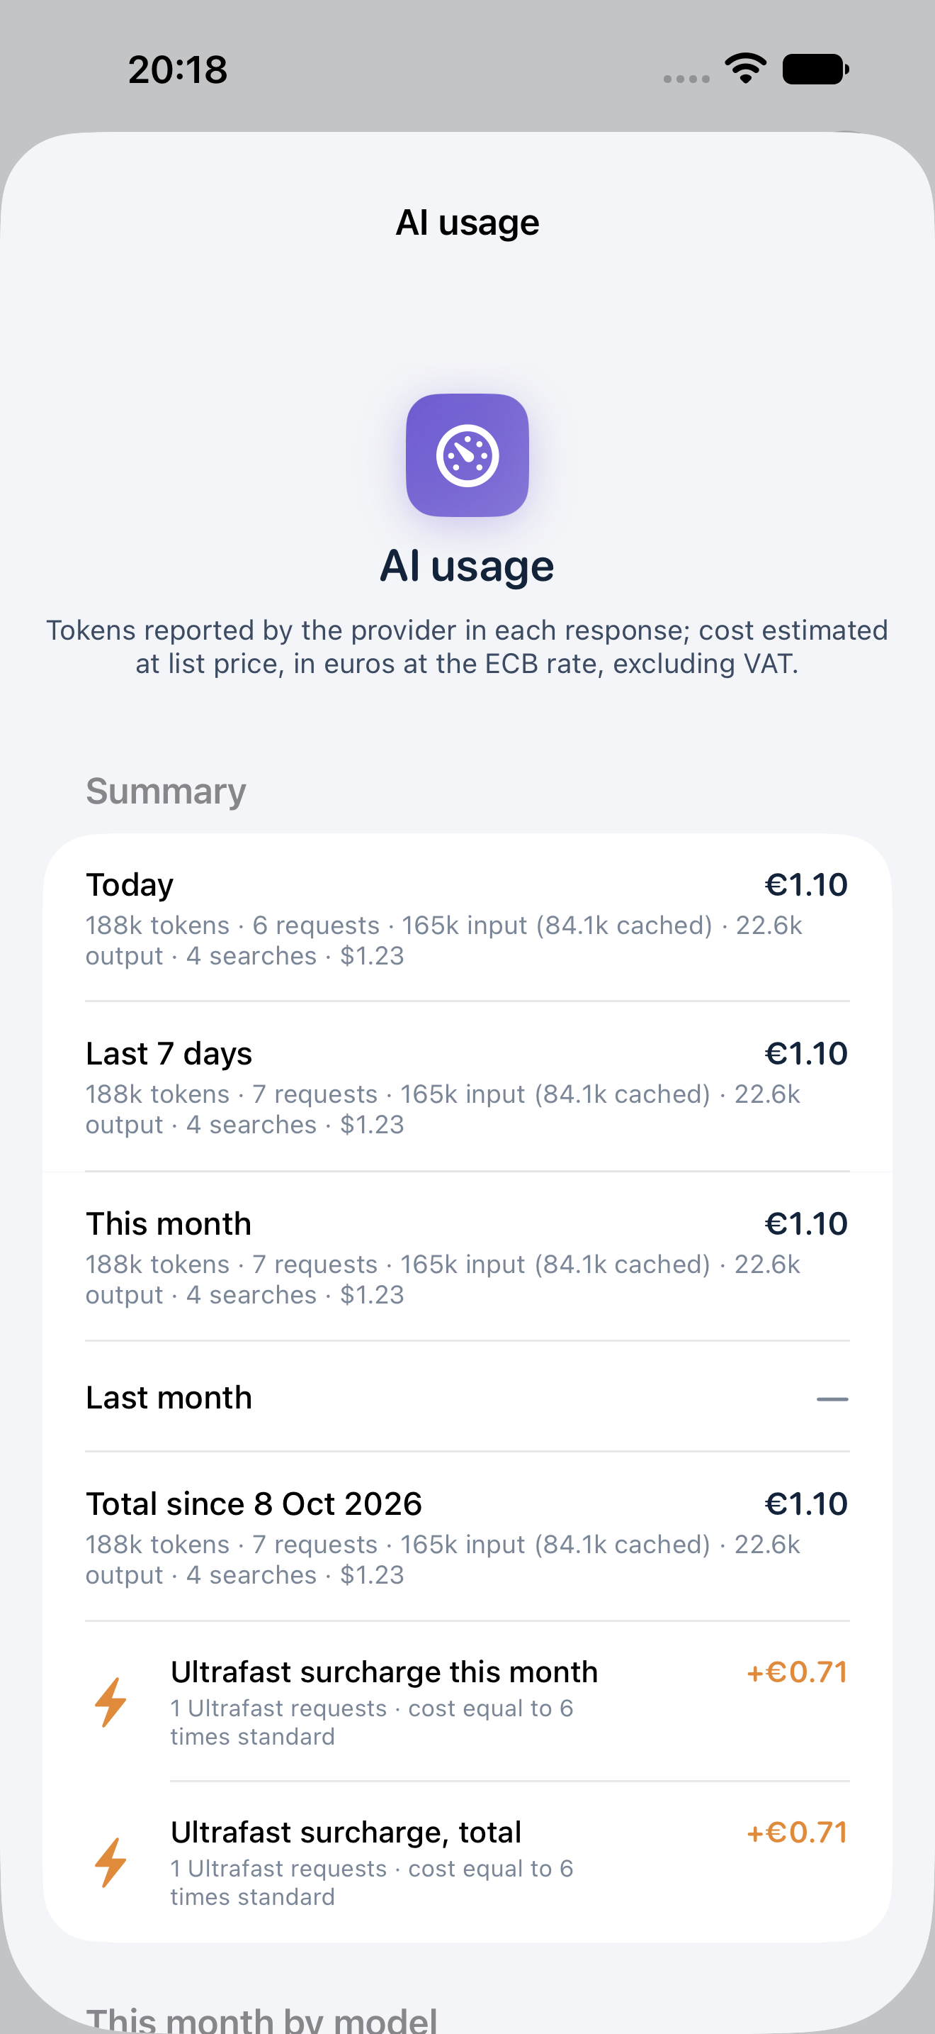
Figure 1 · AI usage in English: synthetic DEMO ledger, euro estimates and Ultrafast surcharge already included in the total. Amounts are not invoices or actually billed calls.

6 · Understand GitHub before setup
A repository is the storage area with history; a branch is a separate version; a pull request or PR is a request page; a job is one processing operation. The token is the app's credential for GitHub. It is separate from Codex's GitHub connection and your Apple Account.
The suggested Rilievo 4.0 repository name is rilievo40-perizie. A prefilled name does not mean the repository exists. Use a dedicated 4.0 repository, separate from the CE app's rilievo-sopralluoghi. You do not need to upload the whole iOS app or commercial source code: the repository holds instructions and the material you choose to send.
1. Sign into GitHub on a computer and verify your email. For an organisation, agree access and approvals with its administrator.
2. Create rilievo40-perizie or your agreed name. Select Private and initialise with a README to provide a default branch, usually main.
3. Check the owner, for example demo-studio, and name rilievo40-perizie. These are separate app fields: do not put the complete URL in Repository.
4. Review collaborators and installed integrations. “Private” does not remove authorised access or anonymise images, invoices, IP addresses or host names.

7 · Create a GitHub token and connect the app
For beginners, create the repository in the browser first, then a token restricted to it. “Create private repository if missing” can require additional permissions and cannot bypass organisation rules.
1. In GitHub open profile > Settings > Developer settings > Personal access tokens > Fine-grained tokens > Generate new token.
2. Choose a recognisable name, expiry and correct Resource owner. Under Repository access select only the 4.0 repository.
3. Give Contents and Pull requests read/write access and Metadata read access. Issues read/write is used for job labels where required by the repository's GitHub operations; do not grant general administrative permissions. Organisation approval may be needed.
4. Generate the token and copy it only into the app's protected field. Do not store it in README files, photos, shared notes or messages. Revoke and replace an exposed token.
5. Open Settings > AI engine > Codex Cloud and read the disclosure. Enter Owner, Repository and GitHub token. Keep @codex as the mention when your integration uses it.
6. Tap “Save and verify”. Check the correct account and reachable repository. Public repositories are blocked. A 401/403/404 is not a successful check.
7. Tap “Publish instructions for Codex (AGENTS.md)”. Wait for confirmation and open the repository: it should include AGENTS.md, _ai/response.schema.json, _ai/result.schema.json and the 4.0 prompts.
The token remains in the app's Keychain. App-to-GitHub access does not prove that OpenAI can read the repository: complete chapter 8. Official GitHub token guidance.

8 · Prepare Codex Cloud on a computer
On 11 October 2026, OpenAI documentation distinguishes current Codex Cloud from Codex Cloud (Legacy). The app's PR and @codex workflow requires an authorised GitHub integration, described as Legacy in the documentation. Publishing a new environment alone does not guarantee that the bot responds to PRs.
1. Sign into ChatGPT/Codex in the browser. Confirm that your plan and workspace allow the required channel; team administrator action may be needed.
2. Connect GitHub and authorise only the 4.0 repository for the displayed Codex/ChatGPT connector. The token on your phone does not configure this connection.
3. For GitHub/Legacy, open Settings > Codex Cloud (Legacy) > “Create environment”, or the page linked by the app (chatgpt.com/codex/cloud/settings/environments). Select repository/branch, check file access and test a PR request. “Migrate” does not prepare the Legacy channel needed for this route: first confirm which method you intend to use. Menu labels may vary.
4. For current Cloud on web/computer, choose Work in > Cloud > Select environment > Create environment. Select the repository, complete and review setup, then publish. Wait for “Environment published”. If this is the only available route, use the manual return in chapter 10 rather than assume a bot response.
5. Analysing uploaded photographs does not require a personal OpenAI API key in the environment. Never put the phone's token into AGENTS.md or prompts. Let the app publish its 4.0 instructions and schemas; do not copy CE templates.
6. If research needs internet, allow the required destinations and test access. Network access does not authorise a service or verify a source.
Checked documentation: Legacy environments, current environments, GitHub integration, Legacy internet access. OpenAI interfaces may change: follow the available workflow and verify the complete round trip.

9 · Choose how cloud jobs start
Settings > Codex Cloud > “Job trigger” offers three modes. “Comment @codex on the PR (integration required)” posts the request on a PR and requires the authorised integration. “Labelled PR only (started externally)” prepares a PR labelled rilievo-job without automatically starting a task. “Manually from Codex Cloud in a browser” prepares work without an automatic mention: start it in the browser. A label is neither a result nor a guaranteed trigger.
The expected sequence is upload material to the private repository, create job/<uuid> branch and PR, process, return complete JSON, import, review and consolidate/close the PR. The app checks job identity and type. “Completed” prose or a readable answer without JSON does not satisfy the protocol.
Open “Codex” and the individual job. “Pull request on GitHub” opens history; “Task in Codex” opens available reasoning/logs. Wait for processing and choose “Sync now” in the assessment panel. Do not manually close/merge the PR before the app imports the result. Changed material may supersede an older job: inspect the current one.
Automatic reminders are spaced and may consume more processing. “Retry” does not guarantee free execution and does not configure a missing environment. Fix the cause first, then recall the correct PR once.

10 · Run a manual task and return JSON
Use this route when automatic triggering is unavailable or your account offers only current Cloud. First disable automatic mentions so two tasks do not process the same job.
1. Prepare one DEMO job in the app. Open its PR and note the job/... branch, <assessment>/_jobs/<uuid>/ folder, primary id and kind in the PR and request.json.
2. Select the environment containing the 4.0 repository and start a task in Codex. Ask it to read the exact PR branch. If it cannot, access is not ready. Do not work only on main when the job is on its own branch.
3. Copy the full PR prompt or give its prompt.md path. Request inspection of the indicated originals and compliance with AGENTS.md and _ai/ schemas. Never request invented missing evidence.
4. Add: “Return the complete JobResponse conforming to rilievo.response/1 with the exact primary job id and kind, status done and complete result. In the 4.0 domain use assessment40/perizia40 as requested; CE risk and survey stay null. Do not truncate JSON.”
5. Review the answer. If an authorised Codex bot posted valid JSON on the PR, sync the app. A human-pasted comment is not treated as a bot response.
6. If there is no importable bot comment, save the full envelope as response.json in the exact job folder on the original PR branch. Explicitly ask the task to write only this file according to the schema, or use GitHub Add file/Create new file on the correct branch. Do not create the file only on main or return an unwrapped assessment40 section.
7. Return to the app, choose “Sync now”, and inspect the result, cited evidence and alerts. Importing a draft does not approve the report.
Text to copy into a manual task after replacing the PR reference: “Process the job in PR [paste the PR link here]. First verify repository and job-branch access. Read AGENTS.md, the _ai files, request.json, prompt.md and the cited originals. Do not invent information or satisfied requirements: preserve gaps, contradictions and HOLD. Produce the complete rilievo.response/1 JobResponse with the job’s exact id and kind, status done and a result conforming to the 4.0 schema. Write response.json in the job folder on the original PR branch, without changing other files or closing/merging the PR. If access or evidence is insufficient, describe the blocker and do not claim successful processing.”
Protocol field names are English and must not be translated. “done” means processing has finished, not that requirements are satisfied: gaps, missing evidence and HOLD must remain in the schema's fields. Do not change UUID, type or structure to force a rejected result through. If the JSON is incomplete, ask for a complete response for the same job without removing gaps. The app can also find response.json in a separate PR referencing the same UUID; beginners should use the original branch to keep the workflow clear.

11 · Create the first engagement and asset records
1. Tap “New appraisal” in the list. Enter client and site, checking address and coordinates even when suggested. For testing use “DEMO Studio” and clearly fictional data.
2. Open the slider button at the top and the assessment panel, then “Appraisal data”. Enter scheme, engagement scope, site visit date and client/legal representative details.
3. Select simple or sworn report according to the engagement and professionally verified scheme. A switch does not create an oath, signature or sworn assessment. Do not carry thresholds automatically from one scheme to another.
4. In “Assets”, tap “New asset” and enter a concrete name. For a complex asset, record its components and their relationship to the main asset.
5. Open “Asset data”. Enter functional catalogue item, supplier, acquisition, order/invoice, amount to verify, delivery, commissioning, interconnection and location. The field labelled “Eligible cost” is an entry field, not a tax calculation or approval.
6. Enter network information, IP, subnet, gateway, MAC, host, DNS, protocols and systems only from verified records. Leave unknown values missing instead of inventing them.
Expert-entered records take precedence over AI deductions in the interface, but inconsistencies still need review. Preserve orders, invoices, delivery evidence and interconnection test records. The plate year alone does not prove these dates.
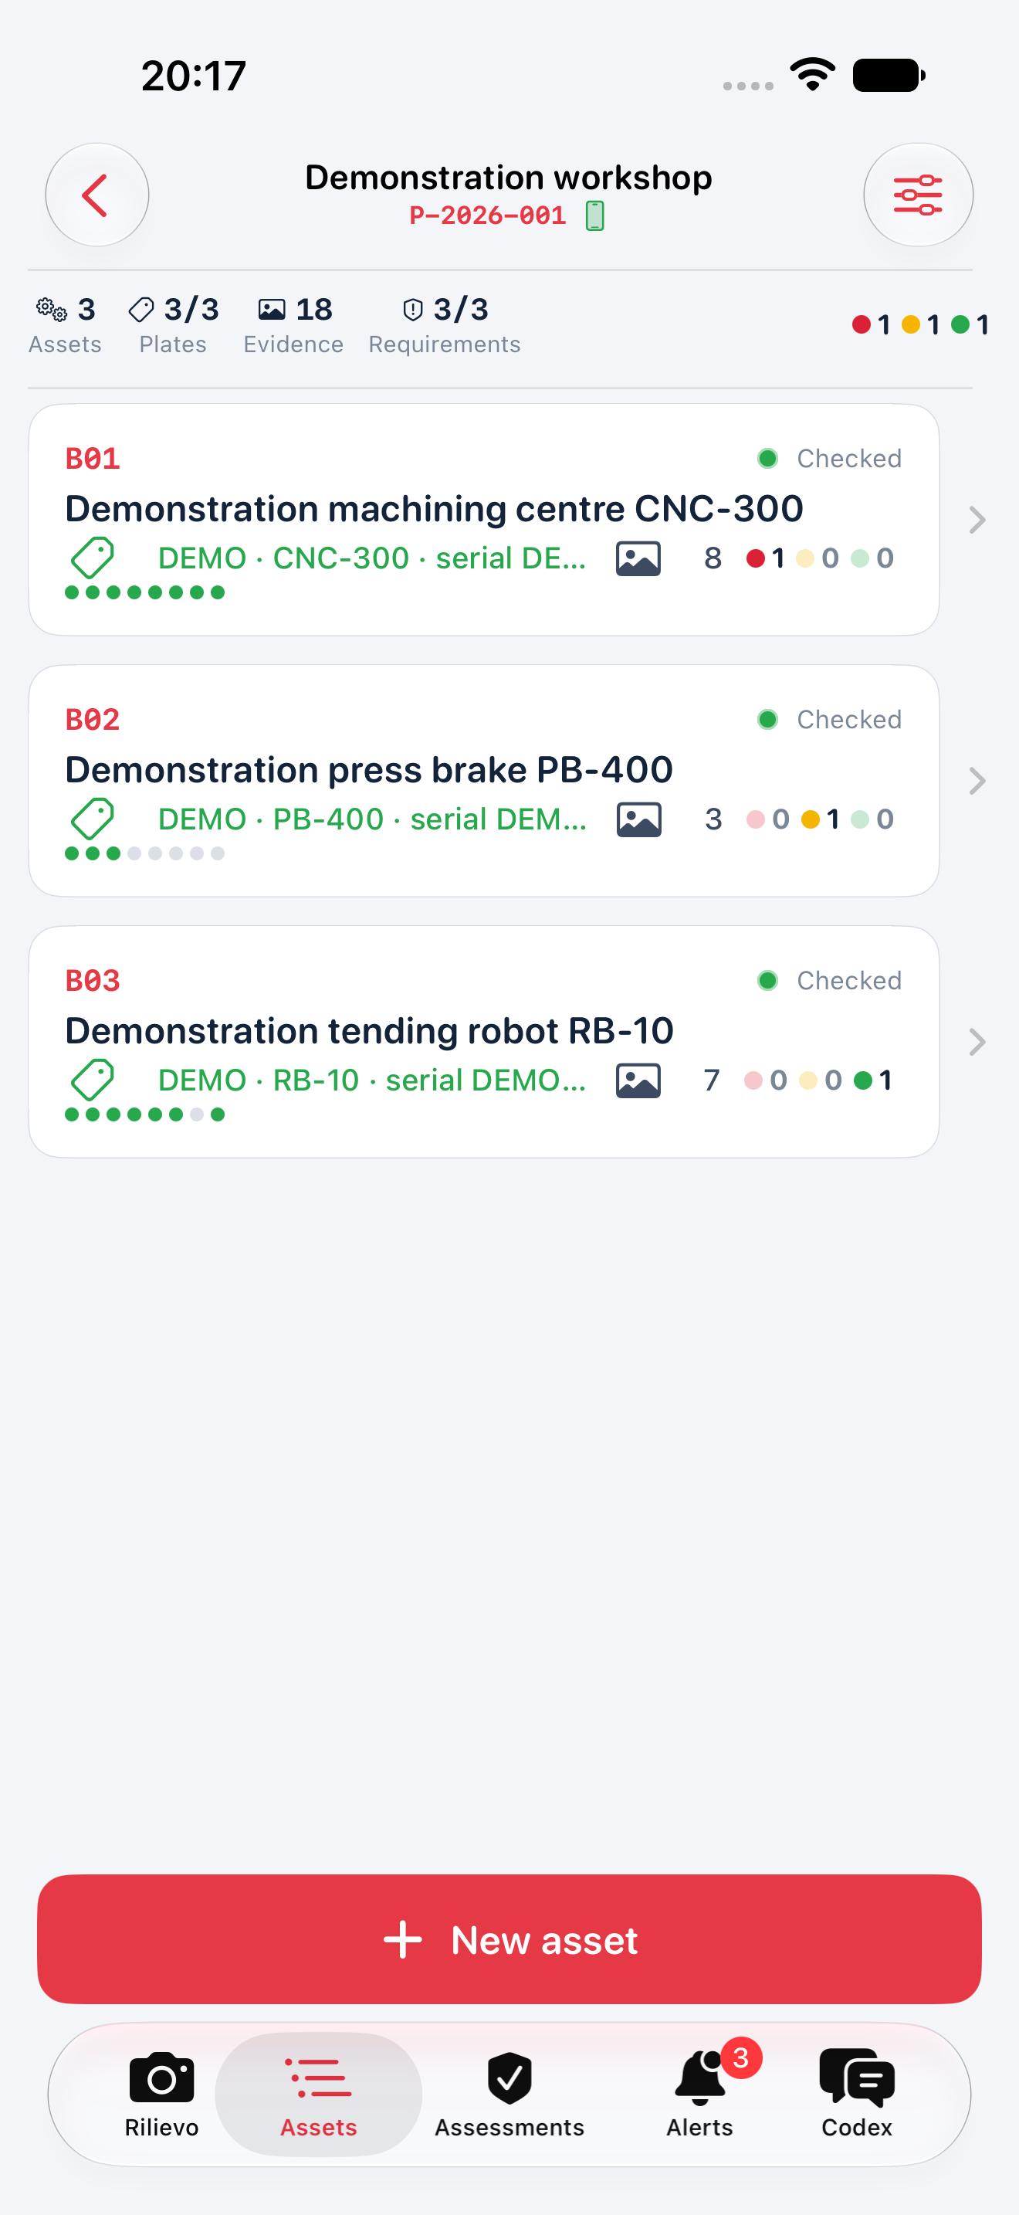
Figure 2 · Three assets in the DEMO appraisal. Coverage dots and processing status do not establish tax eligibility or professional approval.

12 · Capture the nine evidence groups
Group | Material to collect | Concrete check
1 Asset | Overall view in the workshop | Identity and installation context
2 CE plate | Manufacturer, model, serial number, year and documents | Legibility; a plate alone does not complete O5
3 PLC or CNC | Controller and version | Actual connection to the asset O1
4 HMI | Status, alarms, recipes and controls | Interface and operating conditions O4
5 Interconnection | Network and instructions with date/time | Unique identity and documented exchange O2
6 Integration | MES, logistics, suppliers or machines | Actual integration or exchange O3
7 Remote | Maintenance, diagnosis and control | Actual function and documentation RU-a
8 Monitoring | Sensors, parameters and drift response | Continuous monitoring and adaptation RU-b
9 Digital twin | Relevant modelling or simulation | Additional RU-c where used

1. Open “Capture”, select the correct asset in the strip and the evidence group. Scroll for groups outside the screen. The group remains active for later shots: recheck it when changing activity.
2. Photograph context and then detail without glare or cropping. Use “CE nameplate” for group 2 and verify the AI transcription against the original.
3. Use “Document” for multi-page scans. Check edges and legibility before saving to the correct asset. A contract scan can belong to its relevant requirement group; all imports/documents require review.
4. Add arrows after capture: green for visible supporting evidence, yellow for partial/doubtful evidence and red for a critical issue. Arrows guide analysis, not certification. Do not hide required text.
5. In “Evidence by group”, tap a missing group to open the camera with its hint. Correct a mistaken photo group in the photo detail. Reassessment can create another job.
The coverage counter records photographs in eight collection groups; group 9 and documents are excluded. 8/8 does not mean 5+2 satisfied. Additional requirements must reflect the actual asset. Group 9 is unnecessary when two other additional requirements are demonstrated.

13 · Test the complete workflow with DEMO material
1. Disable automations and create a separate test engagement. Do not use client photos, real invoices, credentials, networks or identifiable people.
2. Add “DEMO Asset”, one legible non-confidential image and an arrow. Before cloud transfer check disclosure, private status and the dedicated 4.0 repository.
3. Start only one analysis. Check the active job, channel, PR and messages under “Codex”. For local AI wait for the model; for APIs check provider usage.
4. If Codex needs an environment, finish chapter 8. If it returns text without JSON, follow chapter 10 instead of creating repeated new jobs.
5. Choose “Sync now” when the answer is available. Check asset identity, correct photo references and honest statements about missing data.
6. Request an asset check and engagement summary. Generate a test PDF and choose “Export dossier”. Open ZIP and PDF outside the app and check matching originals and results.
7. Cloud is ready only after transfer, source reading, processing, JSON return, import and content review. A verified token or published environment alone does not complete this test.
The test checks your connection and understandable output, not a real report's validity or every service capability. Repeat it after important account, permission, model, repository or app changes.
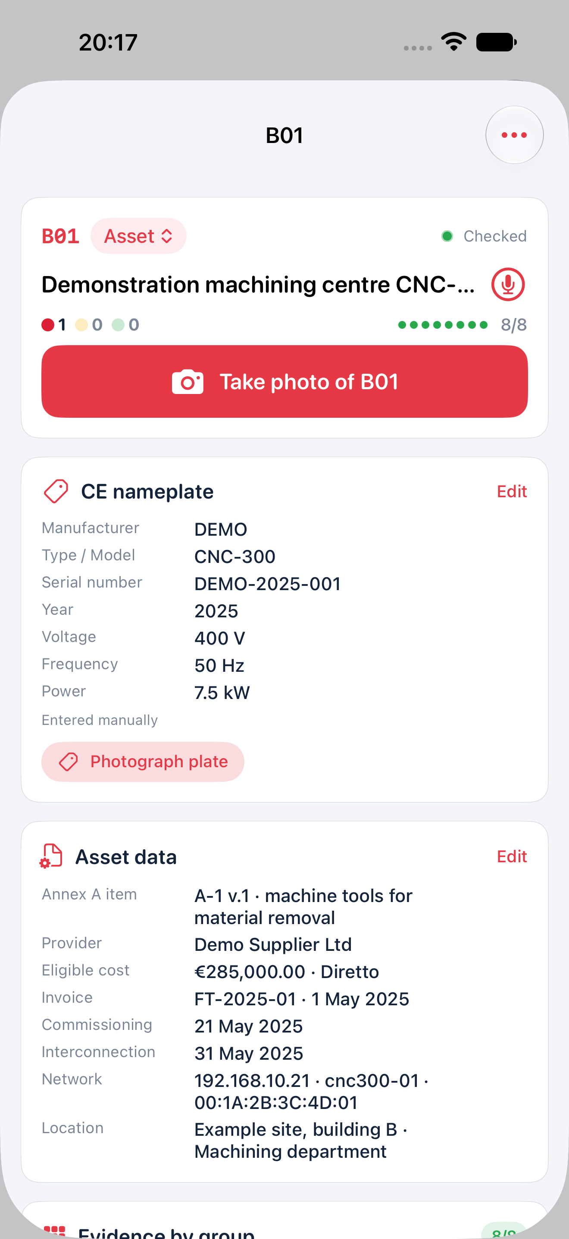
Figure 3 · DEMO asset sheet with nameplate, classification, economic and network data. Dates and amounts are synthetic; entered values do not perform a tax assessment.

14 · Read requirements, findings and alerts
Open the asset's “4.0 requirements check”, then “Open check”. Inspect each finding's status, explanation, evidence codes, extracted information and gaps. “Satisfied” remains a draft finding for review. “Partial” needs completion; “Not demonstrated” lacks sufficient proof. “Not applicable” needs a justified scope and cannot replace a missing mandatory requirement.
Asset findings are “Requirements documented (draft)”, “Evidence to be completed”, “Requirements not demonstrated” and “Incomplete check”. None certifies tax eligibility. The app recomputes its finding from requirements, but computation does not replace classification, site tests or expert responsibility. Software, incomplete classifications and out-of-scope schemes need dedicated assessment.
In “Alerts”, open the request, collect the requested evidence and answer with verified data. A ping alone does not demonstrate the required information exchange; a configured VPN does not prove operational remote maintenance; a CE plate is not a safety assessment. Do not dismiss a gap with “OK” when it remains unresolved. Absence of alerts does not prove completeness.
When AI conflicts with the expert's records, preserve the original, identify the error, correct the relevant input and request one controlled reassessment. Do not change classification merely to obtain a green finding.
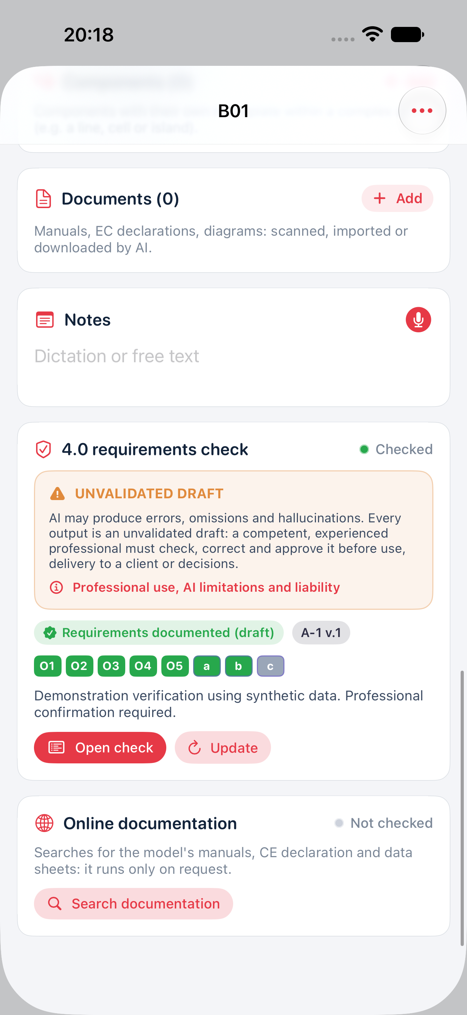
Figure 4 · DEMO 4.0 check with O1–O5, additional requirements and the UNVALIDATED DRAFT notice. The documentary result needs professional evidence review.

15 · Summaries and four PDF report types
The assessment panel provides “Appraisal summary”, syncing, closing collection and “Typeset PDF reports”. Closing an engagement inside the app does not validate, deliver or swear it.
Type | Main content | Reviewed use
PT Technical report | Engagement, assets, requirements, reasoning, gaps and appendices | Overall draft for professional review
SB Asset sheet | Identification, classification and asset findings | Detailed review of one asset
EB Asset list | Register and economic data schedule | Reconciliation with original records
EF Photographic evidence | Organised photographs and references | Consultation of field evidence

1. Choose report, assets and language in the available options. Check heading, professional, dates, engagement information and selected material.
2. Generate and wait for completion. The PDF engine runs on the device. Typesetting does not automatically obtain a missing AI summary.
3. Open every page. Check multi-page tables, photos, identifiers, characters, notices and conclusions. The RAVENG logo identifies the software; it does not show approval or signature.
4. Historical AI content in a different language is not automatically a professionally checked translation. Request appropriate-language material and review it.
5. Unsupported characters may appear as a Unicode sequence [U+....]; compare with originals held in the dossier rather than treating the code as technical data.
6. Export a draft only for authorised review. Apply chapter 16 before external use.
The English catalogue and group labels use non-official service translations of the Italian source. Original Italian catalogue wording is retained in the app and exported data: consult the Italian source for legal interpretation. Application notes, findings and notices follow the report language; separately check entered data and historical AI content, which are not automatically translated.
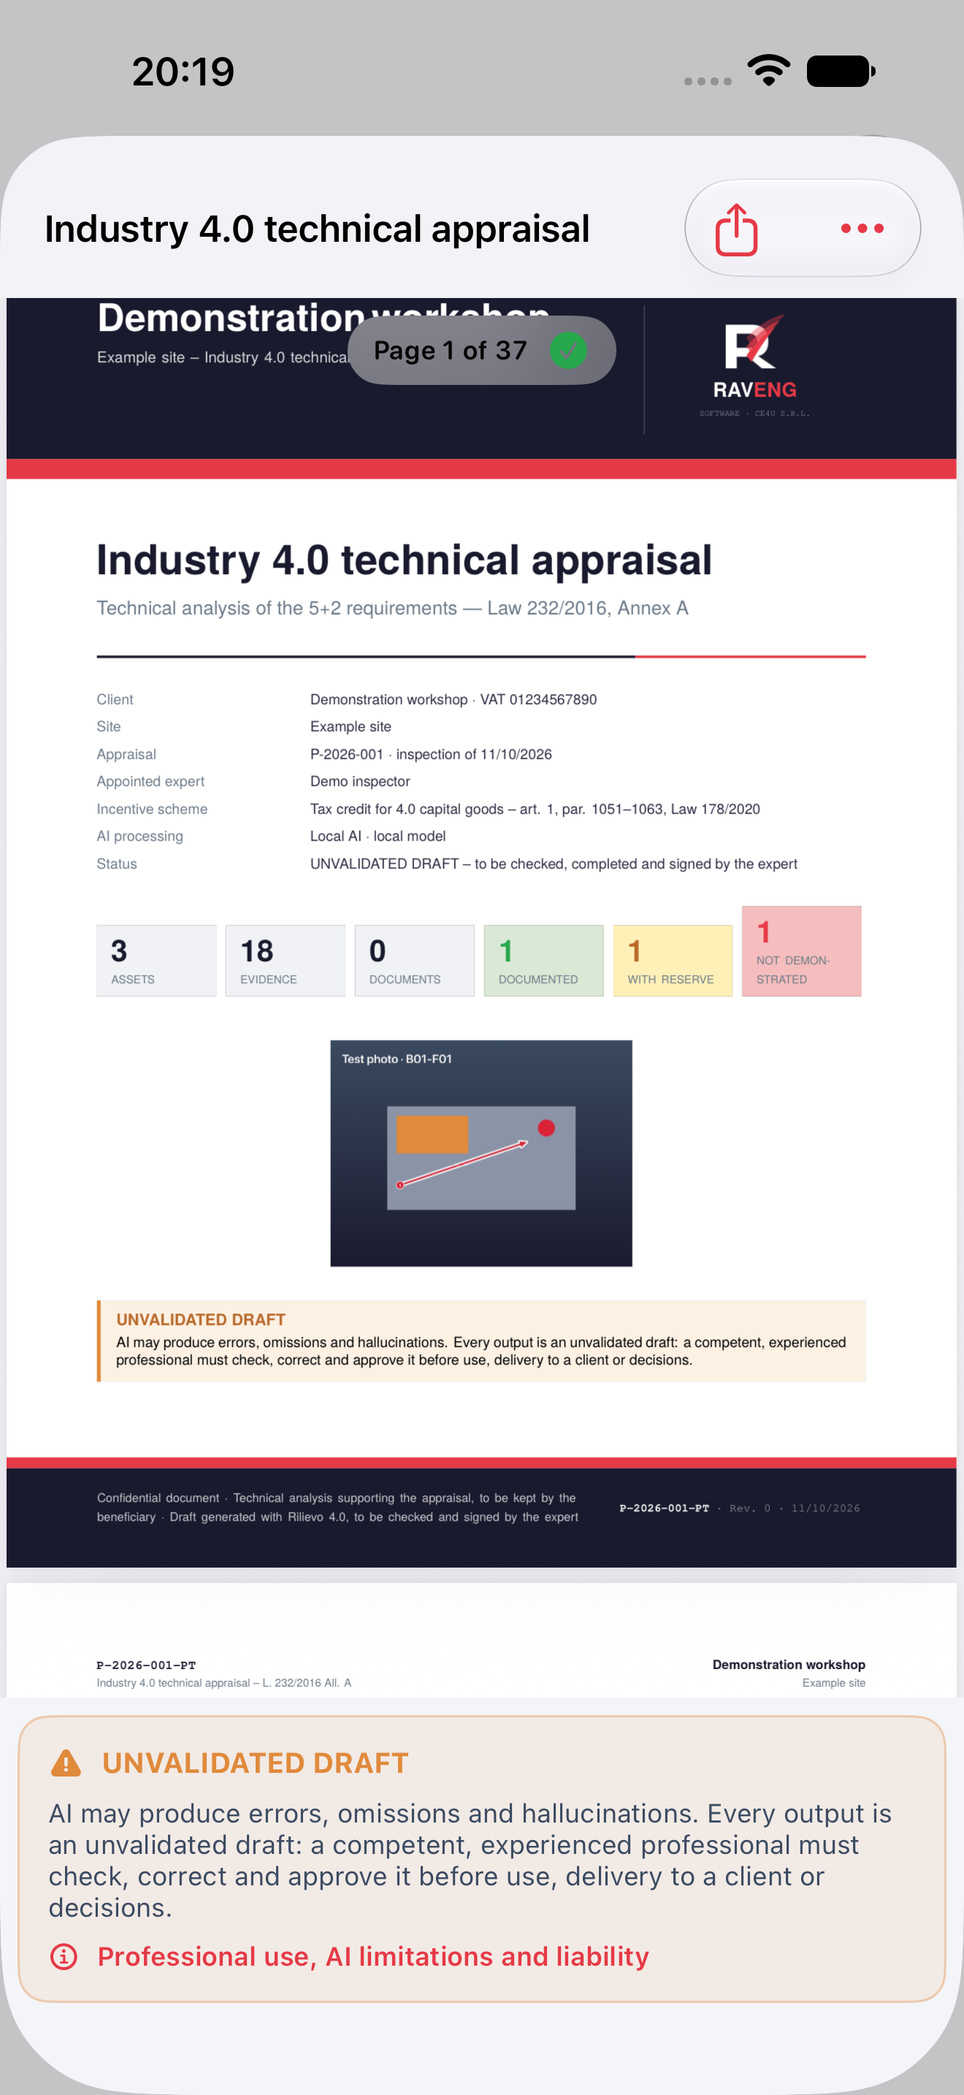
Figure 5 · DEMO PDF preview generated natively by the app, with the draft notice. The document has not been signed, sworn or delivered to a client.

16 · Complete professional checks before signing or delivery
The appointed expert must reconcile each statement with originals and perform checks not carried out by the app. At minimum, review the following.
1. Asset identity/function, complex asset scope, serial numbers, components and correspondence to contracts/invoices.
2. Applicable scheme, period, functional classification and current original sources. No automatic conversion between A/B and IV/V annexes.
3. Order, delivery, commissioning and interconnection dates/records. Reconcile costs and separate mixed items with the tax adviser.
4. Each requirement, actual communication/identification tests, integration, selected additional requirements and safety. Complete missing tests, measurements and site checks.
5. Correct photo/document references, genuinely read primary rules, inconsistencies, missing evidence and eliminated hallucinations. Record limitations and gaps.
6. Additional scheme obligations, signatory qualification, required sworn procedure, retention and delivery method.
7. Final PDF compared with the reviewed version, correct appendices and authorised delivery. Record who checked/approved which version and when.
If material evidence is missing, retain DOCUMENTARY HOLD and do not swear or deliver a definitive conclusion. Reading acknowledgement, export and timestamps do not perform this professional review.

17 · Export, retain and replace the device
1. Choose “Export dossier” in the panel, read the notice and export the draft. Use an authorised Files location or recipient and verify the destination.
2. Open the ZIP and inspect original photos/documents, metadata, AI responses and expected files. A standalone PDF is not the complete evidential record.
3. Keep at least two authorised copies and record engagement, version and export date. Check that they open before deleting material.
4. When changing devices, verify your Apple device backup and retain the ZIP files. Install the same app, restore purchases and check the records before retiring the old device.
For an authorised iCloud backup, connect to Wi-Fi and open iOS Settings > your name > iCloud > iCloud Backup > Back Up Now. Wait for completion and check the last backup’s date/time. If your practice prohibits iCloud, choose an Apple procedure using an authorised computer. Apple iCloud backup instructions.
For Quick Start, enable Wi-Fi and Bluetooth on the old device, place the new device nearby during initial setup and follow the displayed transfer choice. Keep both powered until completion. If the new device is already configured, do not erase it as an improvised fix: consult Apple’s restore procedure and first protect its existing data. Verify appraisals, photos, documents and export access in the app before erasing or disposing of the old device. Apple Quick Start instructions.
“Restore purchases” restores available Apple entitlements, not technical engagements. This version does not promise automatic ZIP import into the archive. GitHub is not a full backup of local originals: cloud copies may be resized. Uninstalling can remove local records; do not use it as the first response to an error.
Deleting an asset/engagement inside the app does not erase GitHub, historical commits, PRs, provider tasks/chats, exports or backups. Apply your practice's retention/deletion policy to external services too.
To delete an engagement, swipe its row left and tap “Delete”, or use the long-press menu. Read the confirmation with its code and client, check that required copies exist, then confirm only the correct engagement. Deleting an engagement does not reset the AI usage ledger, which can retain its code and client name: resetting the ledger is a separate operation. Retain or delete exported CSV files according to your practice's policy.

18 · Purchases, renewal and access after expiry
Open Settings > Subscription, choose Monthly or Annual and read Apple's confirmation before purchasing. You do not need both. Use “Restore purchases” with the same Apple Account used for Rilievo 4.0 to recover an existing entitlement.
The free trial is a two-week introductory offer, equivalent to 14 days, available only when Apple confirms the account's eligibility. You can use only one introductory offer in the Rilievo 4.0 subscription group: changing from monthly to annual or reinstalling does not create another trial. If ineligible, check the paid plan's price before proceeding. Apple introductory-offer rules.
To avoid payment after the trial, Apple says to cancel at least 24 hours before it ends. Do not wait until the last minute: open “Manage subscription” or iOS Settings > your name > Subscriptions > Rilievo 4.0, check the displayed date/time, cancel if desired and verify the resulting status. At conversion, the monthly plan charges €29.90 per month; annual charges €299.00 in one payment in advance per year. Renewal is automatic unless cancelled. Uninstalling does not cancel renewal. Actual access expiry, including after cancelling a trial, is the date indicated by Apple. Official Apple instructions.
After expiry, archive consultation/export remain accessible; new material and new AI work require active access. If purchase verification is pending/unavailable, check connection/account and restore instead of buying a second plan. Refunds are separate procedures under Apple's conditions: Apple refund request.
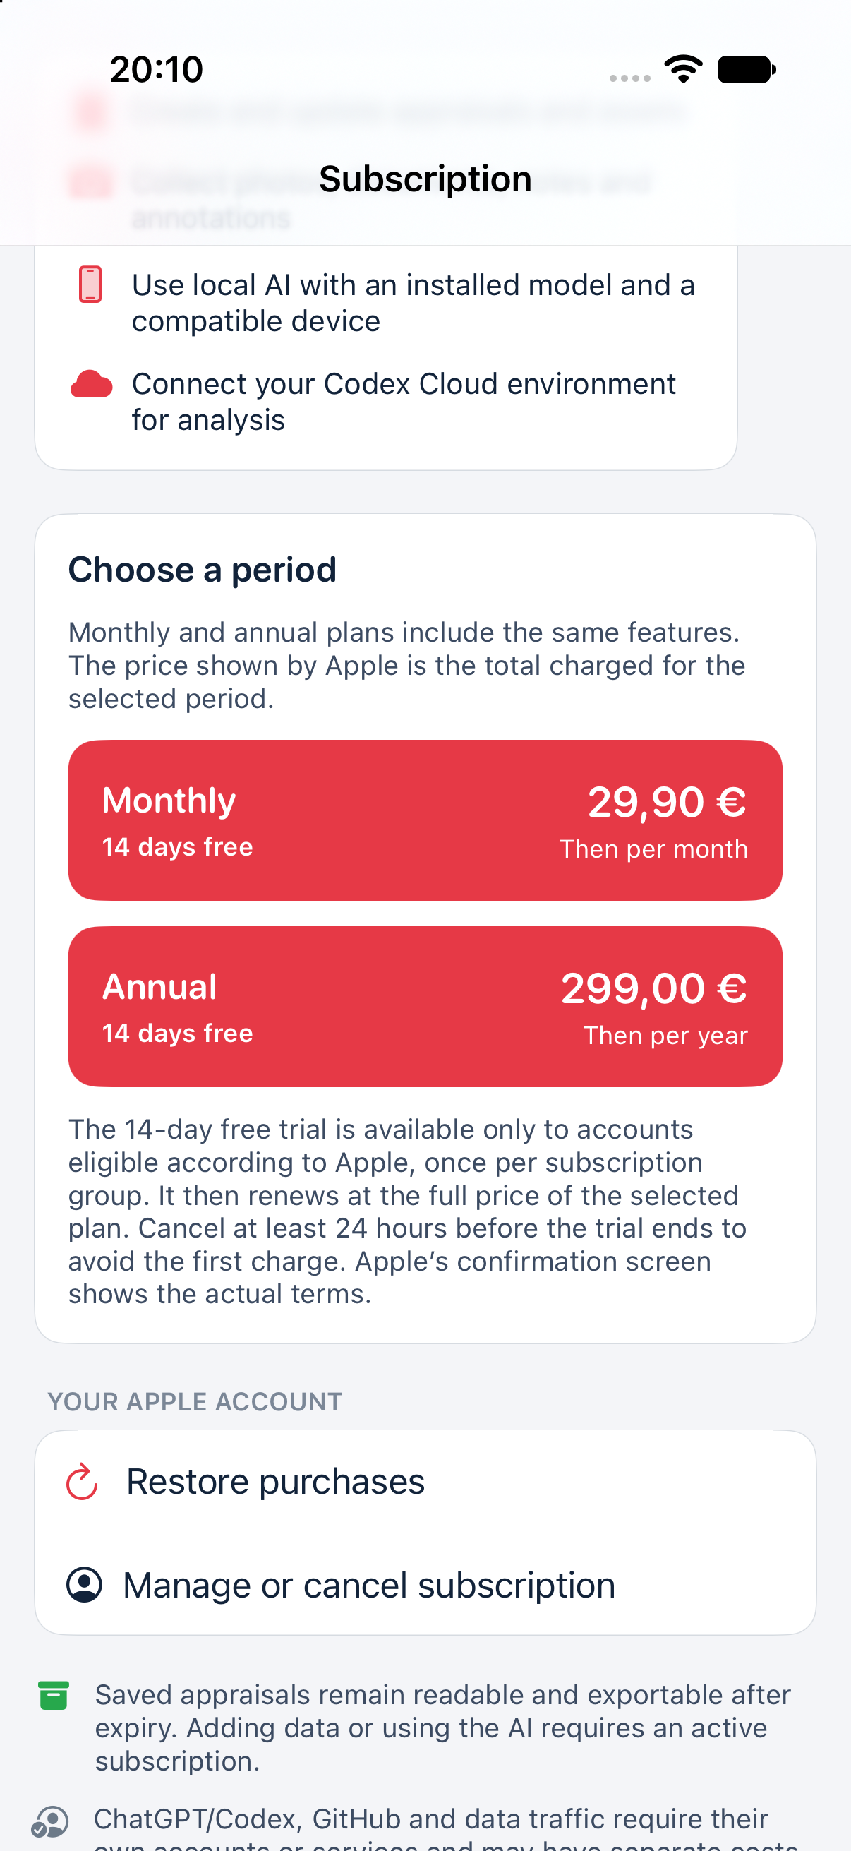
Figure 6 · English interface showing 14 days only when eligible, then full monthly/annual prices. Local StoreKit capture, without a real purchase; Apple’s confirmation determines actual conditions. Prices reflect the Italian test storefront.

19 · Resolve problems without losing records
Problem | First check | Safe next step
Camera blank or denied | iOS permission and real device | Enable permission or import authorised material
Plate or text incorrect | Original image and legibility | Correct manually and take a clearer photo
Local model stalled | Compatibility, storage, memory and download | Wait or choose a lighter compatible model
GitHub 401 | Expired, wrong or revoked token | Replace in the protected field and verify
GitHub 403 | Permissions, SSO, organisation approval and limits | Fix the cause before retrying
GitHub 404 | Owner, repository and authorised access | Check the private repository and token access
Codex requests environment | OpenAI repository access and channel | Complete the correct setup and resume the same job
Cloud setup lacks job files | Correct branch, Git clone and network/proxy | Read logs and fix access; ready schemas do not prove connectivity
Task ended but result missing | Complete JSON, UUID, kind and branch | Request envelope or save response.json in job folder
Result rejected | Superseded job schema or different identity | Use current job without changing its identity
API capacity exhausted | Credit, quotas, model and image access | Check provider account not another app purchase
Ultrafast unavailable | Supported model, access and tier limits | Read the job and standard fallback before repeating
AI cost incomplete | Unpriced model, units and available records | Set correct rates and reconcile with the provider
Purchase unconfirmed | Apple Account, connection and verification | Restore without duplicate purchase
PDF incomplete | Selected material, summary and free space | Keep previous version and regenerate after checking
Archive cannot open | Local error or migration | Preserve device, backups and exports; contact support

Before “Retry”, record the error, time, version and job. Do not delete the engagement, publish the repository or remove protections to bypass a failure. Processing already performed can be billable even if a result has not arrived.

20 · Privacy, support and licences
Before cloud use verify client authorisation, personal data, lawful basis, notices and relevant agreements. Avoid people, health data, passwords and secrets in images. Rilievo 4.0 does not automatically anonymise photographs, plates, invoices, IP addresses or host names. Channel acknowledgement does not replace external authorisation and obligations.
If cloud use is prohibited, leave it disabled and consider compatible local inference while checking device backups/sharing too. Revoking a channel blocks new transfers; it does not withdraw copies already sent. Follow providers' deletion procedures and your engagement's retention requirements.
The AI usage ledger is local and separate from the engagement archive; it can retain up to 50,000 records and discard the oldest. Periodically export the data needed for reconciliation. Records and CSV may contain client name, engagement code, asset, model and activity: treat the CSV as confidential. Deleting an engagement does not delete these records. Use the separate reset only after retaining what is required, and consider exports and backups too. Do not send a complete client ledger to support when a DEMO example is sufficient.
Settings > Model licences provides attributions, original texts and the PDF engine's third-party source package. These are third-party components, not the complete commercial app source code. Preserve attributions with permitted redistributions.
Contact Rilievo 4.0 support with app version/build, iOS, device model, AI channel, a DEMO code or job UUID and the error. Share only authorised necessary material without keys/passwords. Read the English privacy notice and Italian site.
Retain the DEMO test outcome, granted-access list and versions for a verifiable setup. Physical camera, local inference, purchases and the cloud round trip need testing in your actual environment; a guide or demonstration screen does not certify them.

